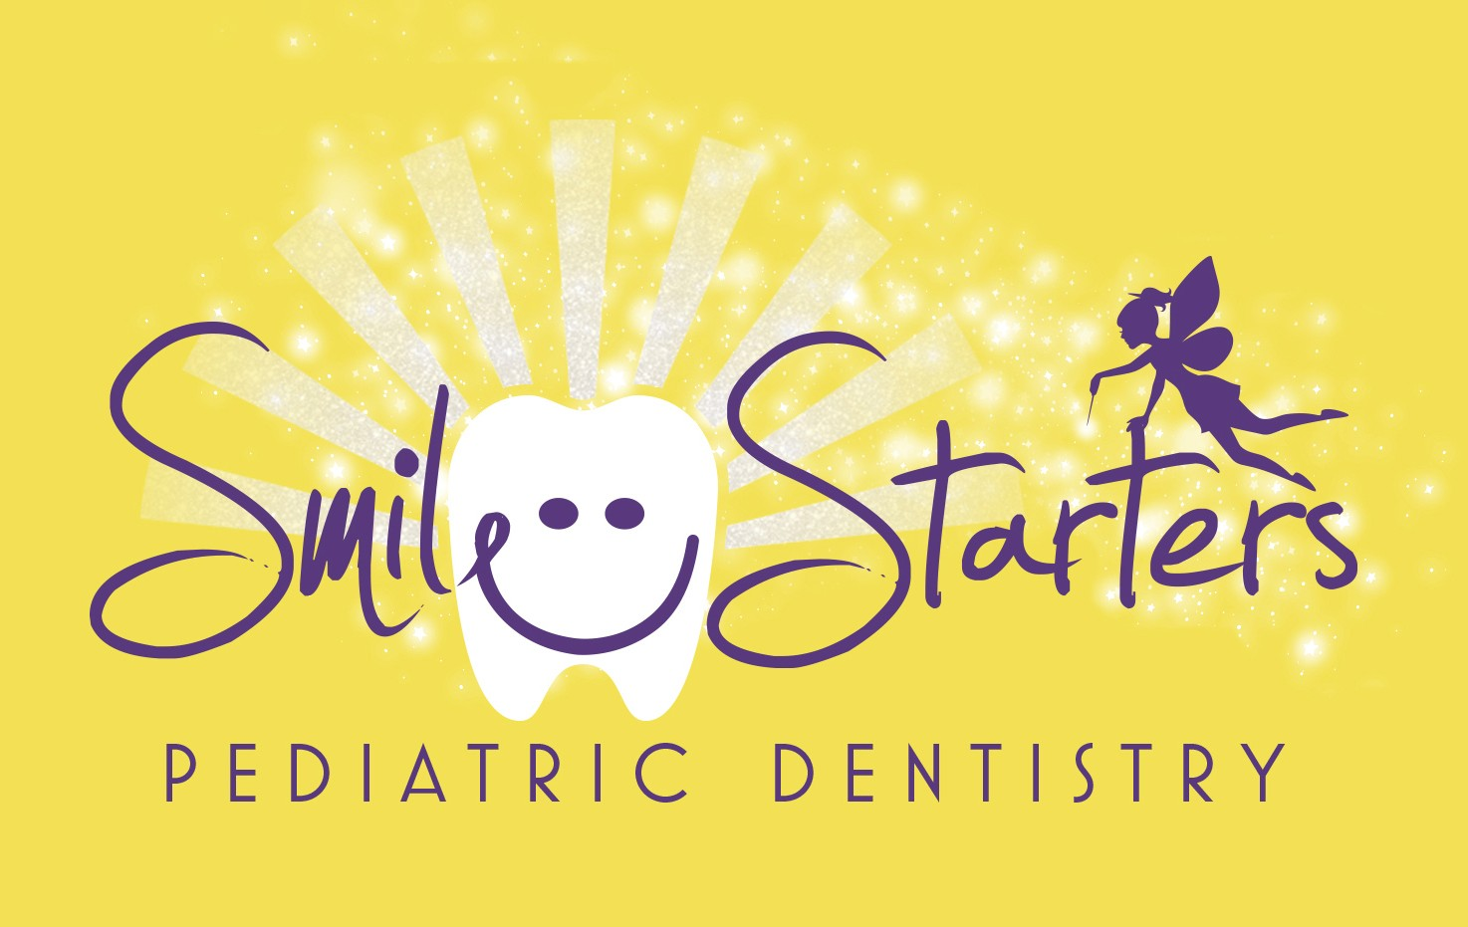
Welcome to Smile Starters Pediatric Dentistry!
CRISTINA B. GEORGESCU, DDS
EILEEN DANO CALAMIA, DDS
450 MAMARONECK AVE. SUITE 403 HARRISON, NY 10528
TEL: (914) 777-1140 FAX: (914) 777-1139

We are thrilled to welcome you and your family. Please fill out this form as completely as possible. If you have any questions, we are happy to help.

Patient's Information and Health History

Child's Full Name Nickname

Date of Birth

Age Sex: □ M □ F Grade Patient lives with: □ Mother □ Father □ Both □ Other

Name(s) and age(s) of other children in family Name(s) of other children seen in this office Whom may we thank for referring you to our office? Is this your child's first visit? Yes No
Who is your family dentist?
Parents' Marital Status □ Single □ Married □ Separated □ Divorced □ Widowed

Guarantor/ Guardian of Child (also responsible for account)_____
Guarantor Relationship □Mother □Father
□Guardian □Stepmother □Stepfather
Date of Birth SS # Address City State Zip Primary (Daytime) Phone Secondary (Cell) Phone Email Driver’s License # State

Secondary Contact
Name Relationship □Mother □Father
□Guardian □Stepmother □Stepfather
Date of Birth SS # Address City State Zip Primary (Daytime) Phone Secondary (Cell) Phone Email Driver’s License # State

Insurance Information - Please give all your insurance cards to the receptionist. If no insurance, check here: Self Pay

Primary Insurance Relationship to Patient Employer Group # Member ID

Secondary Insurance Relationship to Patient Employer Group # Member ID

Pharmacy Information

Name Phone Address SMILESTARTERSPD.COM

Medical History

Child's Name:___________________________________________________________________
Child’s Physician Phone
Is your child currently under the care of a physician for a specific reason? □ Yes □ No
If yes, please explain: Please describe your child's current physical health. □ Good □ Fair □ Poor
Are all immunizations up-to-date? □ Yes □ No
Does your child have any allergies to latex/medications (Penicillin etc) /food/other? □ Yes □ No
If yes, please list:

Has your child been diagnosed with or treated for any of the following:

- AIDS/HIV
- Anemia
- Any Hospital Stays/Surgeries
- Asthma
- ADHD
- Autism
- Cerebral Palsy

- Cleft Palate/Lip
- Diabetes
- Epilepsy/Seizures
- Hearing/Speech Issues
- Heart Disease
- Heart Murmur
- Hemophilia Type

- Hepatitis Type
- High / Low Blood Pressure
- Kidney Problems
- Learning Disabilities
- Liver Problems
- Sinus Problems/Sleep Apnea
- Tuberculosis (TB)

If yes to any of the above or other not listed, please explain

Please list all medications your child is taking

Dental History

What is the primary reason for your visit today?

Does your child currently have problems with any of the following?

- Cavities
- Gum Infection
- Toothache

- Tongue habit
- Oral habits
- Bites fingernails

- Tooth Alignment
- Speech
- Trauma

- Color of Teeth
- Sensitive Teeth
- Other

Has your child experienced problems with previous dental work? □ Y □ N
Please explain

Previous Dentist Date of last visit Why did you leave your last dentist?

Authorization and Release
To the best of my knowledge, the questions on this form have been accurately answered. I understand that providing incorrect information can be dangerous to my child's health. It is my responsibility to inform the dental office of any changes in my child's medical status. I also authorize Dr. Georgescu and Dr. Calamia perform necessary dental procedures including, but not limited to, the use of nitrous oxide, local anesthesia and take any necessary radiographs to diagnose and/or treat my child's dental needs. I also authorize Dr. Georgescu and Dr. Calamia to release any information including the diagnosis and the records of treatment or examination rendered to my child during the period of such care to third party payer and/or other healthcare practitioners.

Signature of Patient (or Parent/Guardian if minor) Relationship
Please Print Name Date

SMILESTARTERSPD.COM

